<https://www.youtube.com/watch?v=adNcCJ0L5O4>

Source Transformation Basic Problem

<https://www.youtube.com/watch?v=0tlIIhlNbsk>

Source Transformation with dependent source (Current dependent source)

<https://www.youtube.com/watch?v=jg_SPiM3bgI>

Thevenin Theorem with Load Resistance

<https://www.youtube.com/watch?v=FQX_pfFMIf0>

Superposition Examples

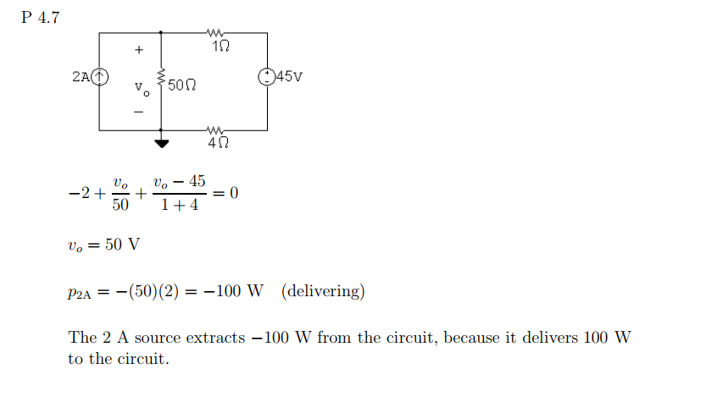

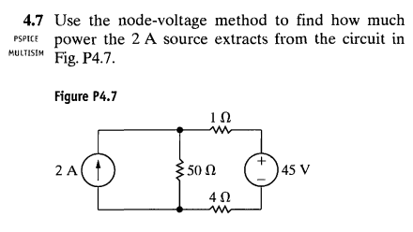

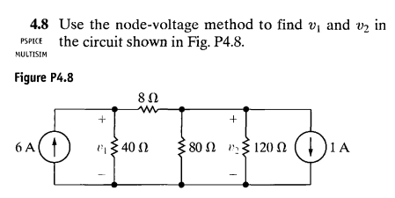

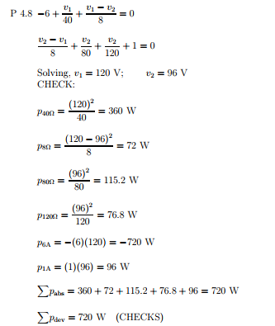

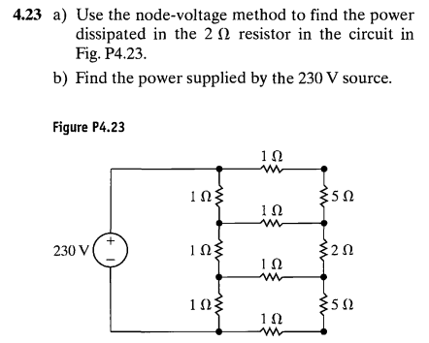

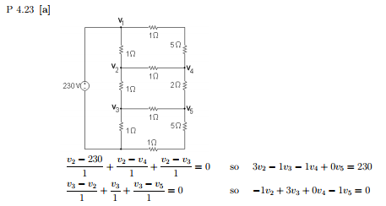

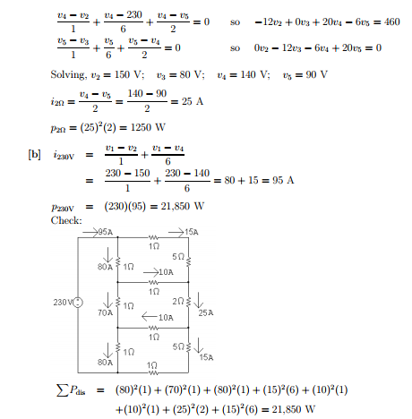

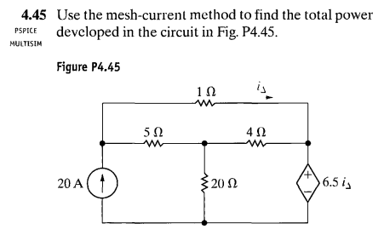

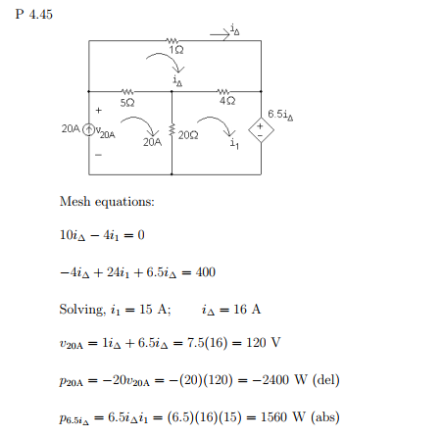

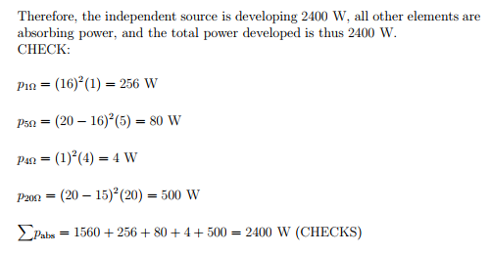

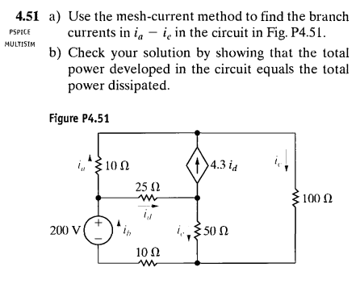

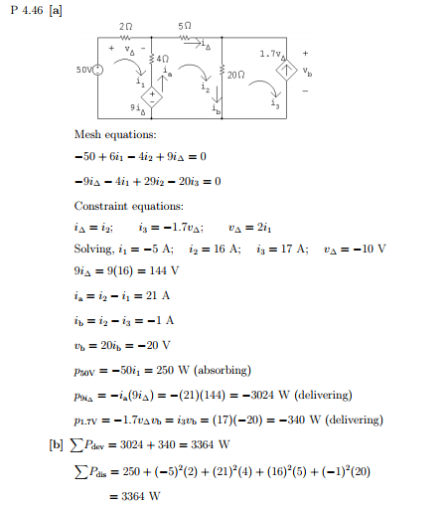

[**https://www.youtube.com/watch?v=eRQ4Ha5yiXQ&list=PLQLdKyBqWCjqpieLy7IK5rEpNeaiDLT3G**](https://www.youtube.com/watch?v=eRQ4Ha5yiXQ&list=PLQLdKyBqWCjqpieLy7IK5rEpNeaiDLT3G)

**Calculate the maximum of Power Transfer**